Naan mudhalvan project

India’s Agricultural Crop Production Analysis (1997-2021)

College : Arignar anna government arts college for women, walajapet,

Ranipet district -632 513

Department of mathematics

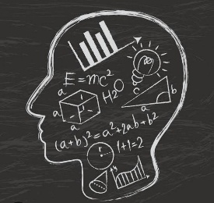

**Topic India’s Agricultural Crop Production Analysis (1997-2021)**

Submitted by

Team leader: Kanchana P

Team members:

1. Kanchana P
2. Jagadeeshwari K
3. Jayasri S
4. Jothilakshmi S

**Introduction**

**Overview**

India’s agricultural production from 1997 to 2021 has undergone significant changes and transformations. With a vast agricultural sector that contributes to the country’s GDP and employs a large portion of the population, understanding the production trends and patterns is crucial.

Over the years, India has witnessed both fluctuations and growth in agricultural production. Various factors such as weather conditions, government policies, technological advancements, and market dynamics have influenced these trends.

It is essential to analyze the production of key crops, livestock, and other agricultural commodities to gain insights into the sector’s performance. Additionally, understanding how India’s agriculture has evolved in terms of yield, production methods, and sustainability practices is crucial for planning future strategies and policies.

In this analysis, we will explore the agricultural production trends in India from 1997 to 2021. We will examine the performance of major crops such as rice, wheat, sugarcane, cotton, and pulses, as well as livestock production. We will also discuss key drivers behind the changes in agricultural production and their implications for the sector’s growth and development.

**Objectives**

The objectives of analyzing India’s agricultural production from 1997 to 2021 are as follows:

1. Identify and analyze the trends and patterns in the production of major crops such as rice, wheat, sugarcane, cotton, and pulses over the years. This will help understand the growth or decline in production and any major fluctuations.
2. Examine the production trends in livestock, including dairy, poultry, and meat. Evaluate the changes in production quantity and any shifts in the market dynamics of livestock products.
3. Identify the factors influencing the changes in agricultural production, including weather conditions, government policies, technological advancements, and market dynamics. Understand how these factors have impacted the performance of the agricultural sector.
4. Analyze the yield levels and productivity improvements in different crops and livestock categories. Explore the role of technological advancements and farming practices in increasing productivity and ensuring sustainable agricultural production.
5. Understand the implications of changing agricultural production trends for food security, rural employment, and rural development. Evaluate the impact on farmers’ livelihoods and explore potential strategies for enhancing agricultural productivity and sustainability.
6. Provide insights and recommendations for policymakers, agricultural organizations, and stakeholders to design effective strategies and policies for promoting agricultural growth and addressing challenges in the sector.

By meeting these objectives, we aim to gain a comprehensive understanding of India’s agricultural production trends, their drivers, and their significance for the overall growth and development of the agricultural sector.

**Purpose**

The purpose of analyzing India’s agricultural production from 1997 to 2021 is to gain insights into the performance and trends of the agricultural sector over the years. This analysis serves several purposes:

1. Identify growth and decline patterns: By analyzing the production trends of major crops and livestock, we can identify periods of growth and decline in agricultural production. This information helps us understand the factors and events that drive these patterns and allows for better planning and decision-making.
2. Assess the impact of policies and interventions: Government policies, subsidies, and interventions play a crucial role in shaping agricultural production. Analyzing production data helps us assess the effectiveness of these policies and identify areas where improvements or modifications may be needed.
3. Understand the drivers of production changes: By studying the factors influencing agricultural production, such as weather conditions, technological advancements, and market dynamics, we can gain a deeper understanding of the forces that shape the agricultural sector. This knowledge can inform future strategies and initiatives.
4. Evaluate food security and sustainability: Agriculture is a key component of food security, and analyzing production data helps assess the availability and accessibility of food. Additionally, understanding the sustainability practices adopted in agricultural production allows for the assessment of environmental impact and the identification of areas for improvement.
5. Support policy and decision-making: The insights gained from analyzing agricultural production data can help policymakers and decision-makers in designing effective strategies and policies to promote agricultural growth, improve farmers’ livelihoods, and ensure food security.

Overall, the purpose of analyzing India’s agricultural production from 1997 to 2021 is to provide a comprehensive understanding of the sector’s performance, identify key trends and drivers, and offer recommendations for sustainable and inclusive growth in the agricultural sector.

**Problem definition and design thinking:**

**Empathy map:**

Empathy maps help identify patterns and themes that are important to your project, enabling you to understand the real problem to be solved.

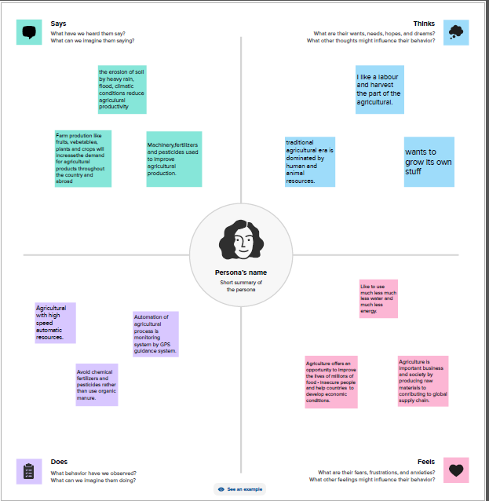

**Ideation and brainstorming map:**

An ideation mind map is a visual diagram that helps you organize and structure your thoughts and ideas. It works by creating a central idea or concept, and then branching out into smaller, related ideas that connect to the central idea.

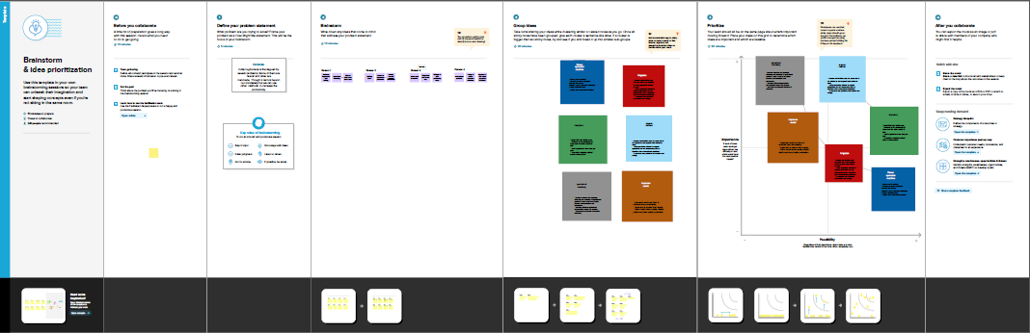

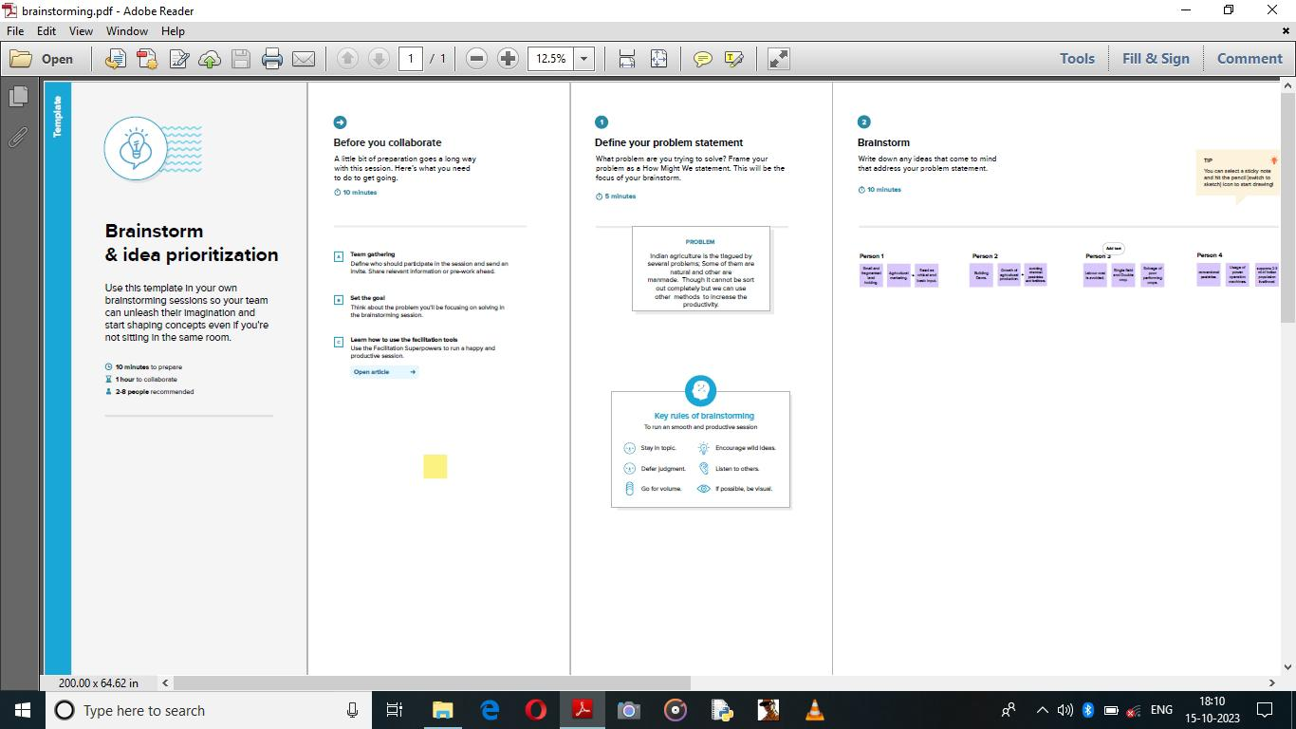

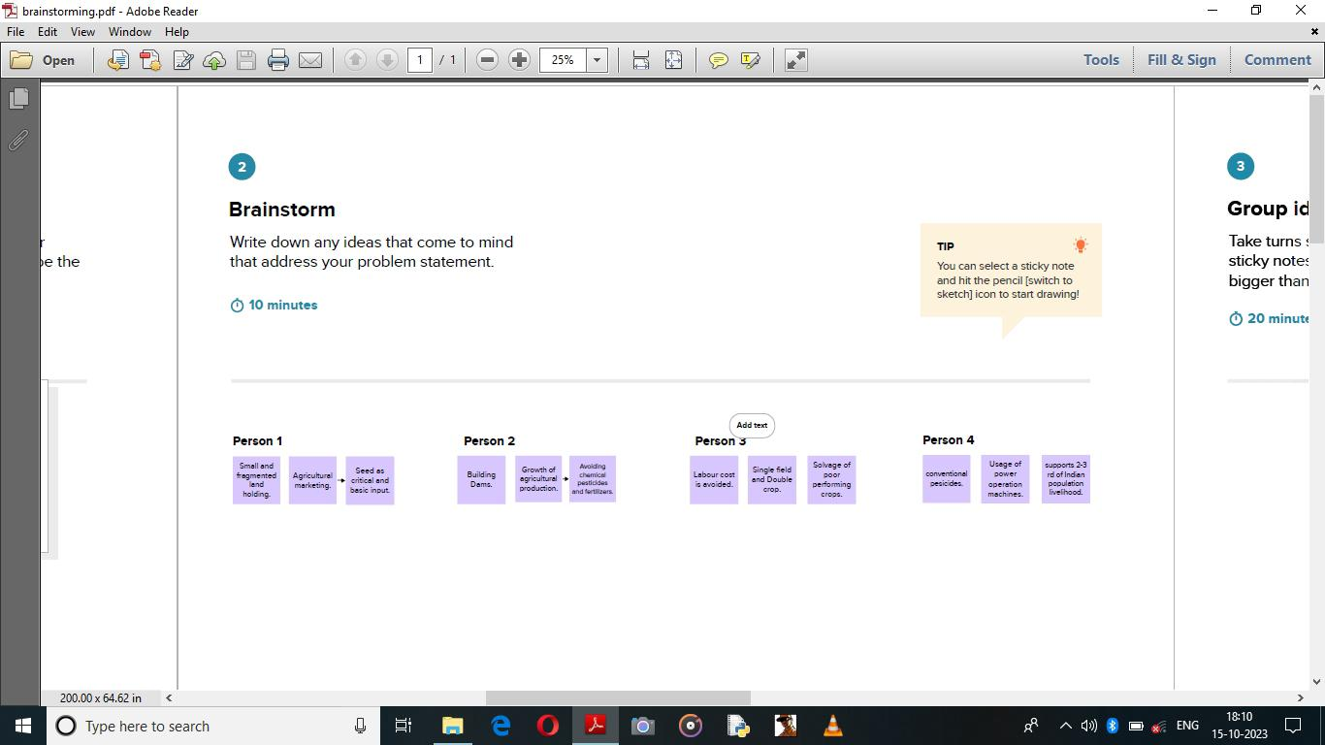

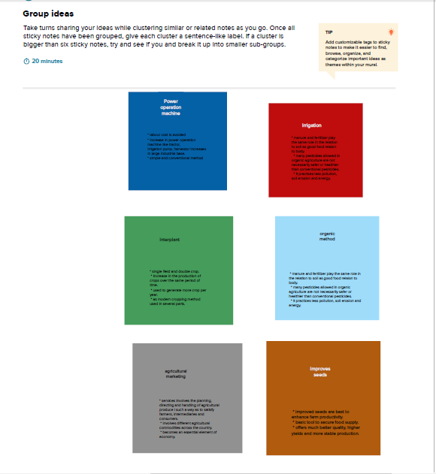

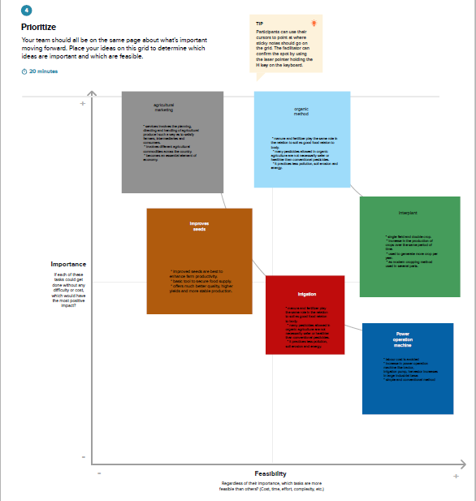

**Source of Data**

Data is open available on Kaggle which is made available Ministry of Agriculture and Farmers Welfare of India

<https://www.kaggle.com/datasets/pyatakov/india-agriculture-crop-production>

**Worksheets**

1. State wise agricultural land

This worksheet explicits about state wise agricultural area in map visualisation.

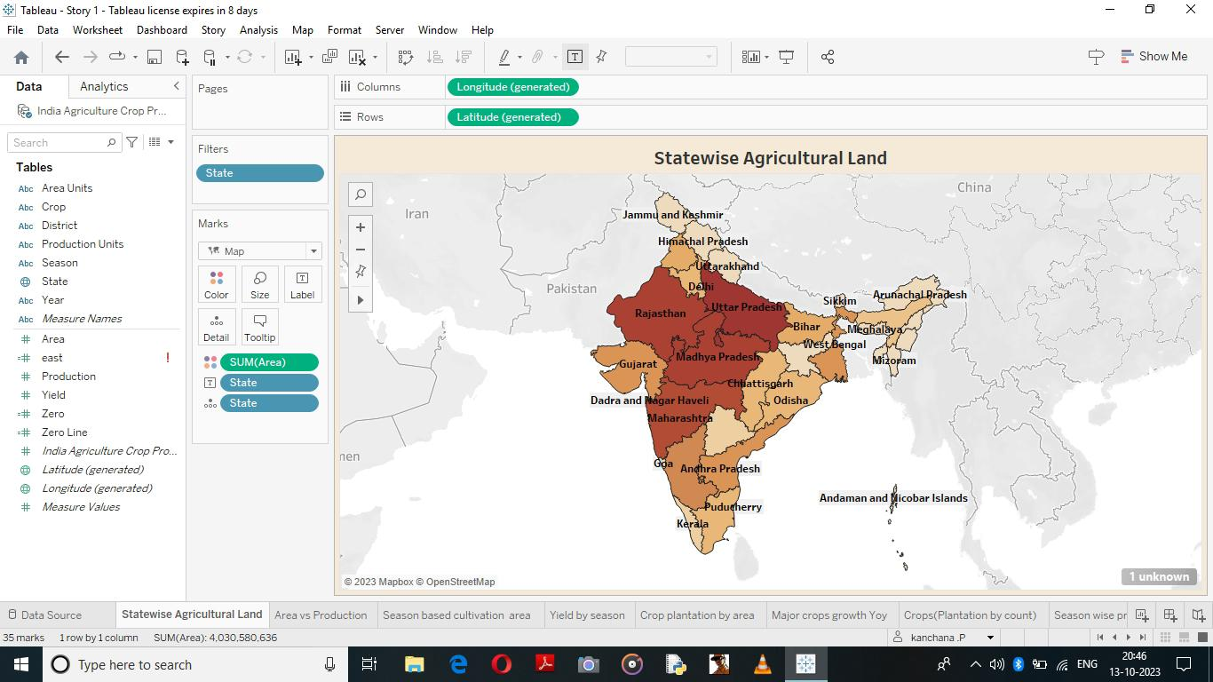

2)Area vs Production

In this we can visualize the production is respected state using horizontal bar diagram

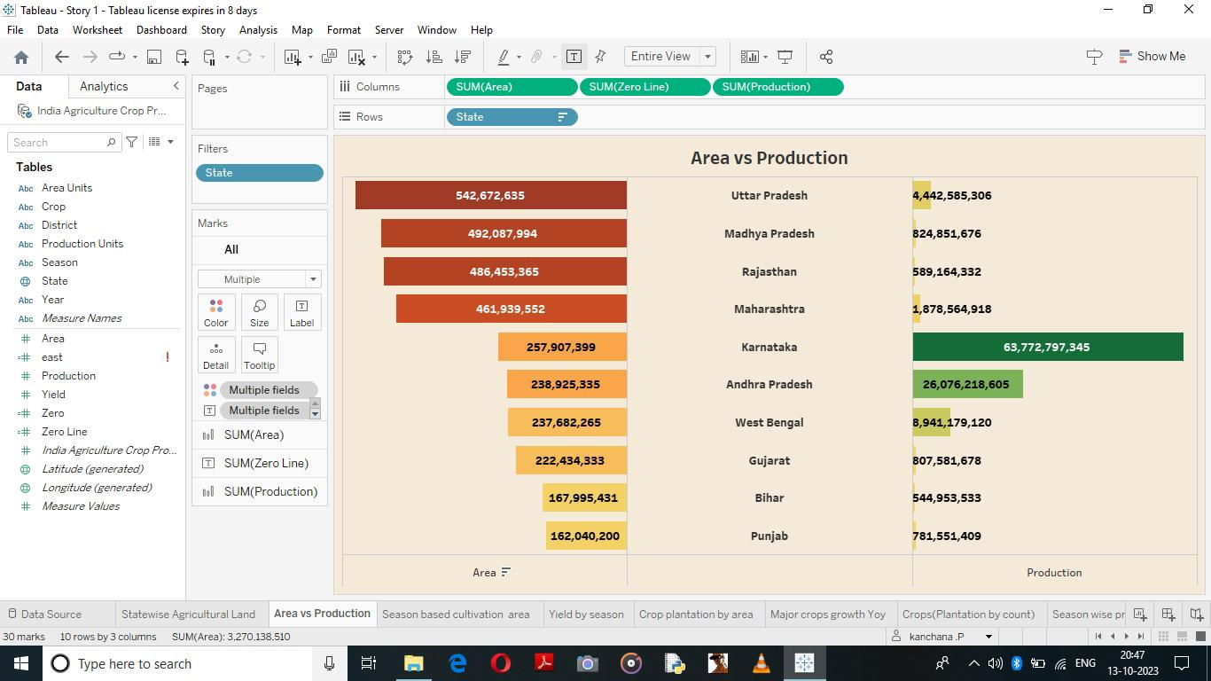

3) 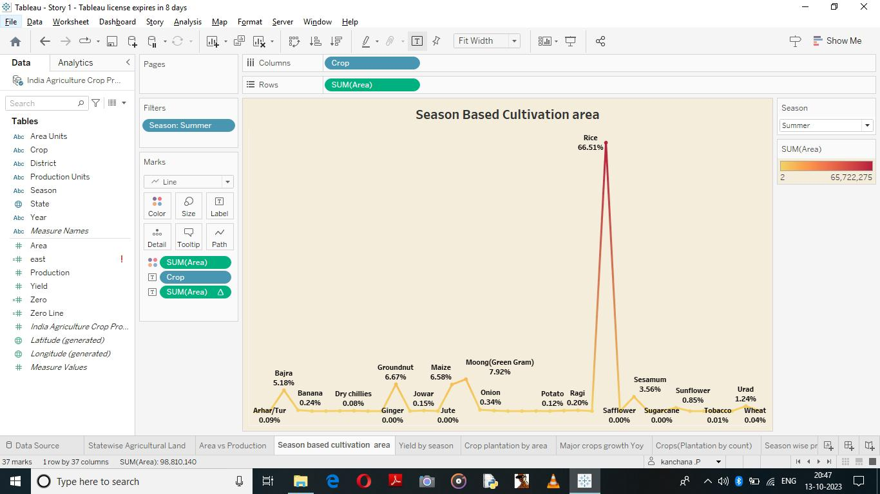Season based cultivation

The worksheet tells about the Crop grown in the area with line chart

4)Yield by season

The visualization is about the season wise yield in their respected year.

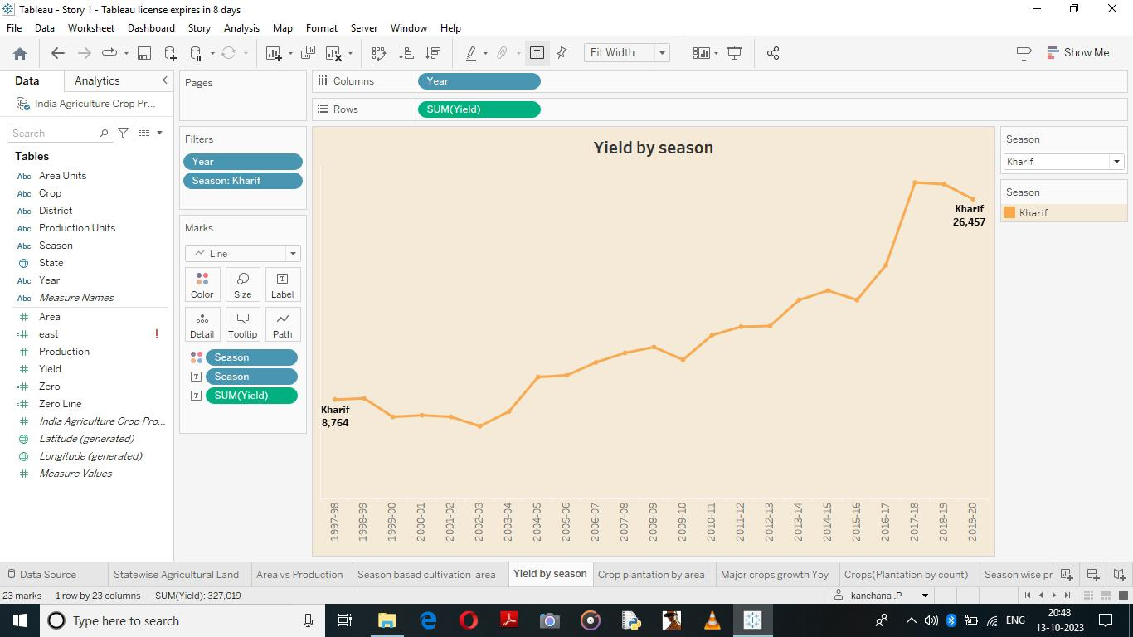

5) Crop plantation by area

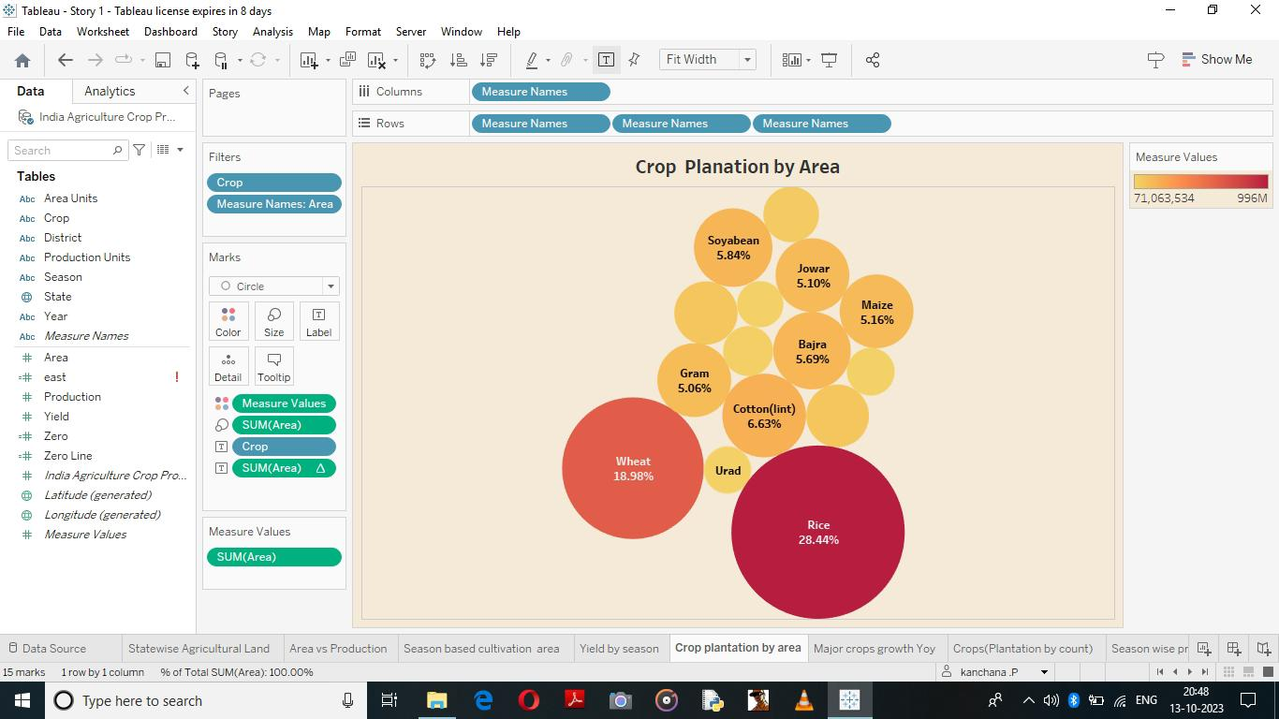the worksheet is about the Crop grown in area with their percentage visualized in packed bubble diagram

6)Major crops grown Yoy

The worksheet tells about the Crop production in year and area percentage difference of production 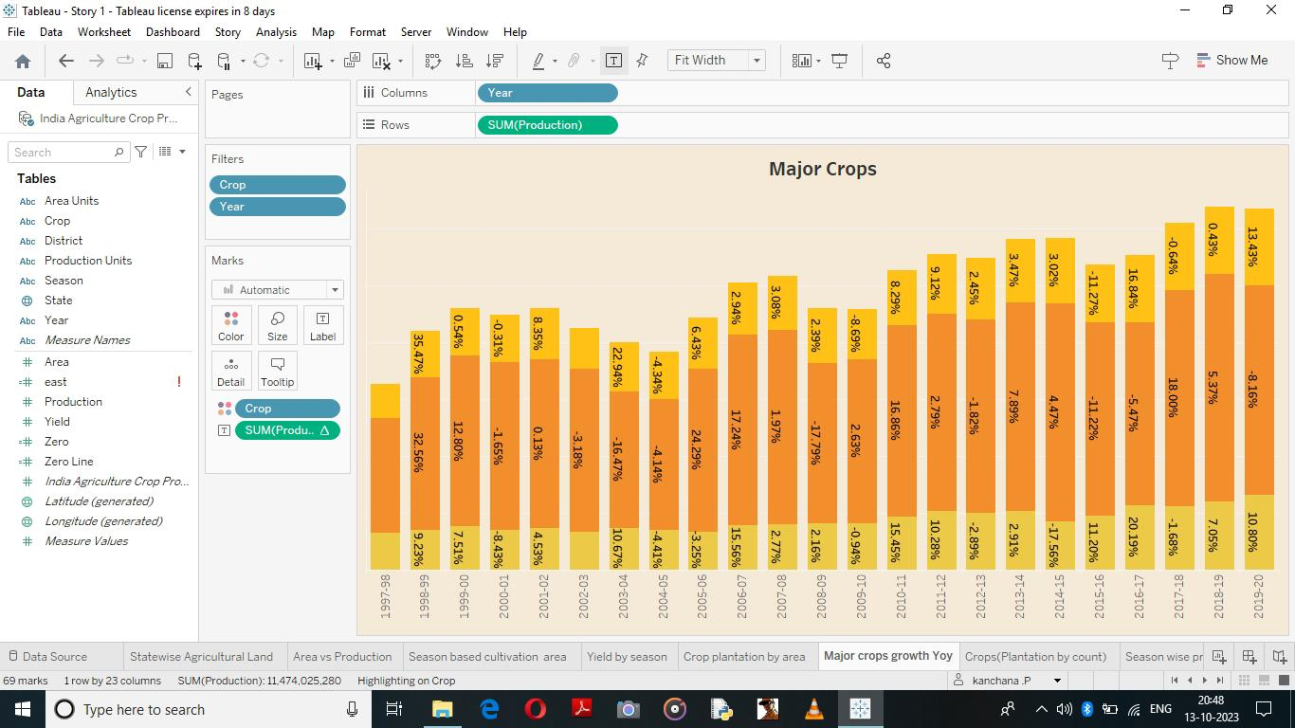

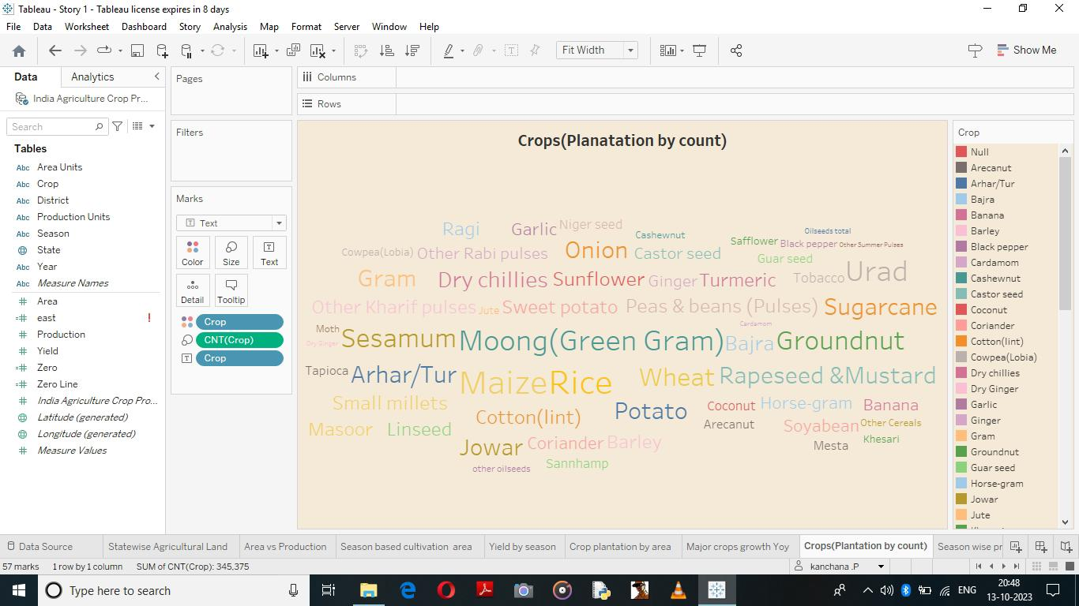7)Crops

The visualization tells about crop and count of crop

8) Season wise production

The worksheet tells about season and production

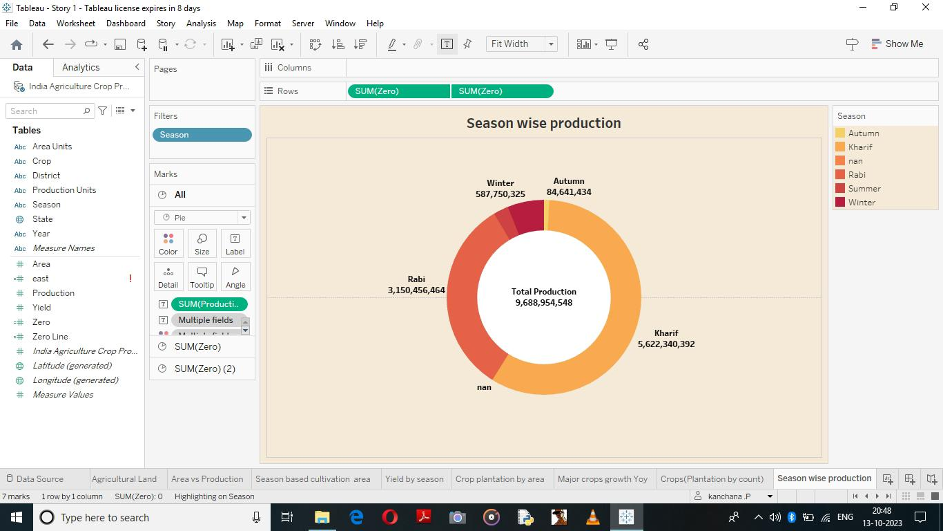

9)kpi’s









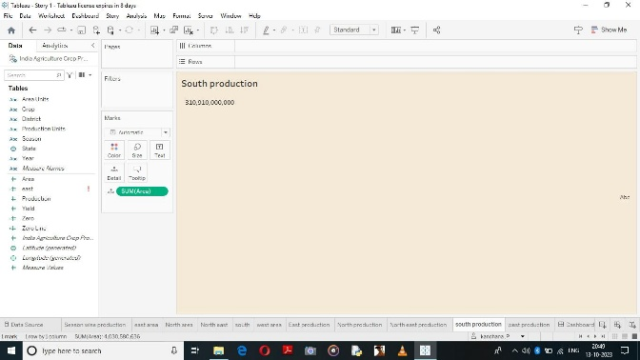

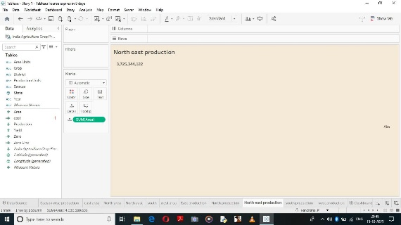

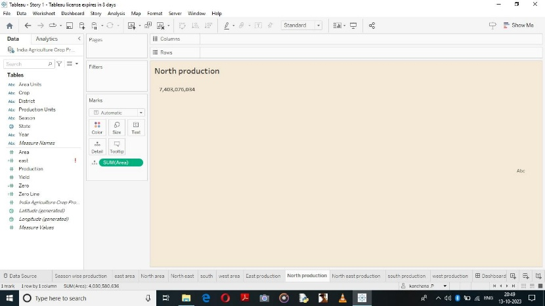

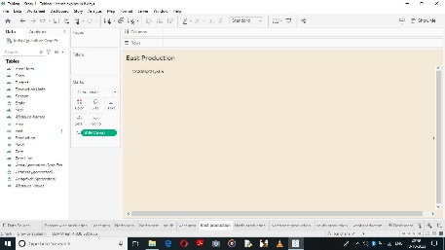

**Dashboard1**

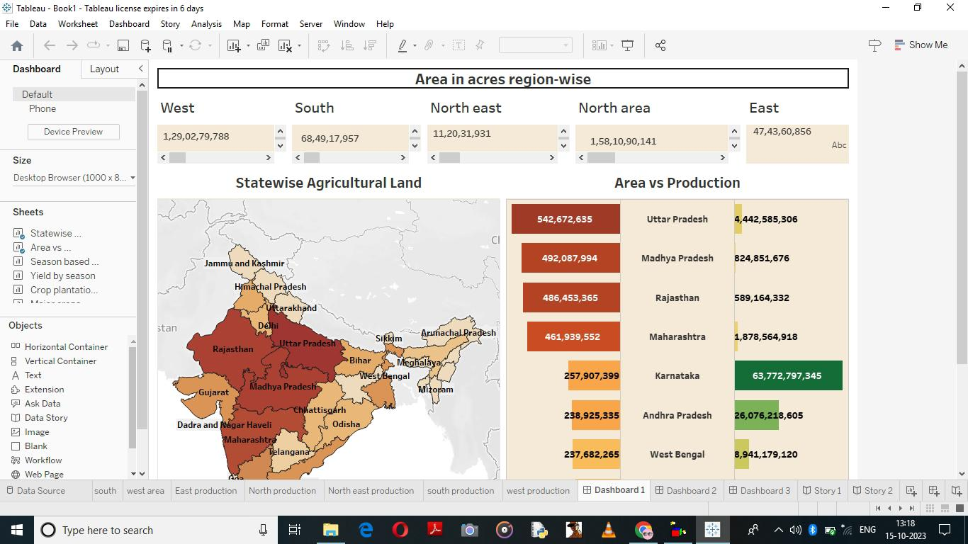

**Dashboard 2**

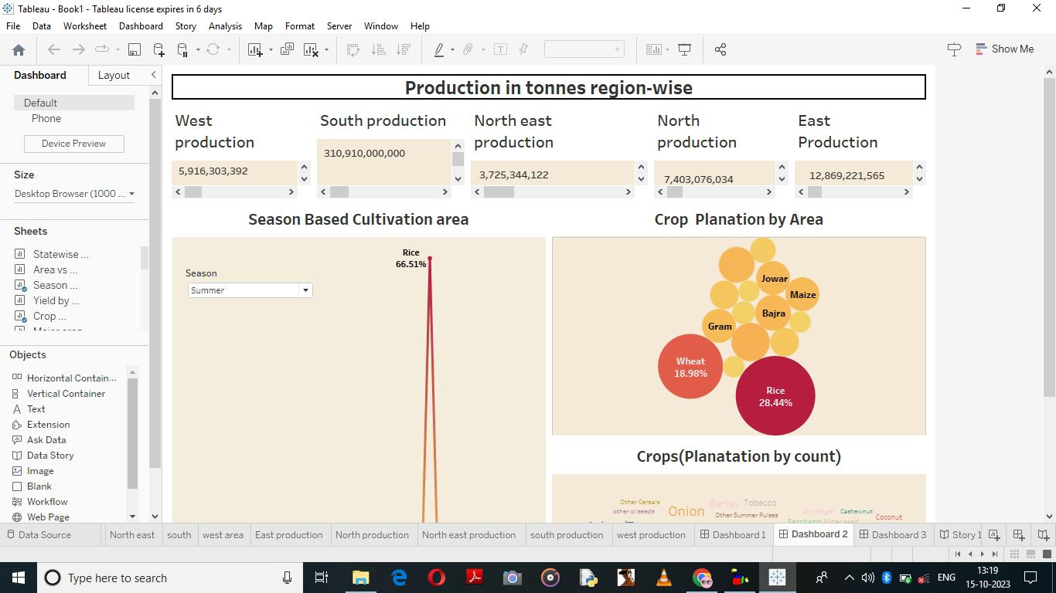

**Dashboard 3**

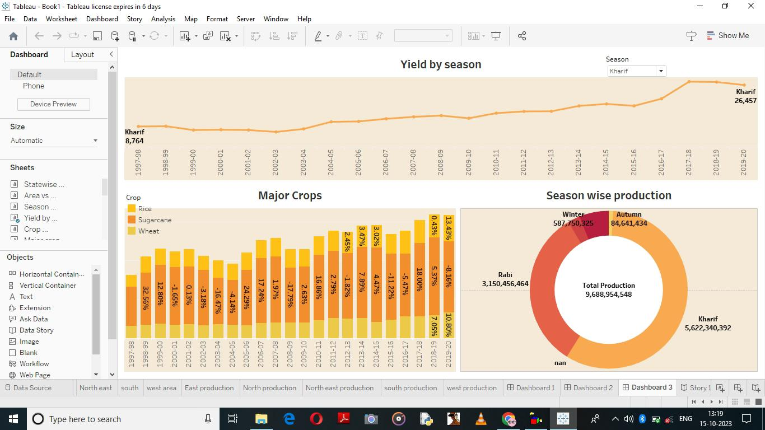

**Story 1**

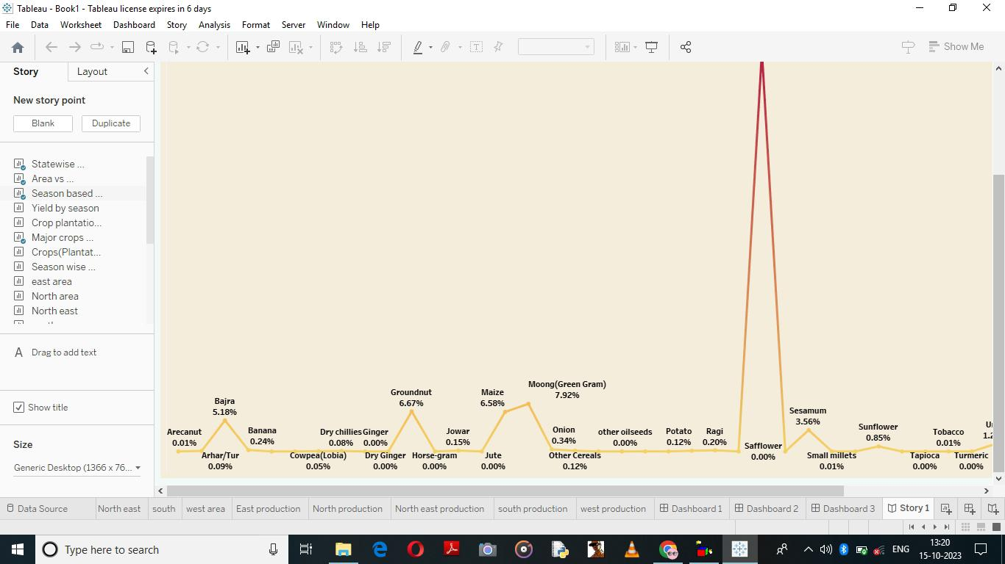

**Story 2**

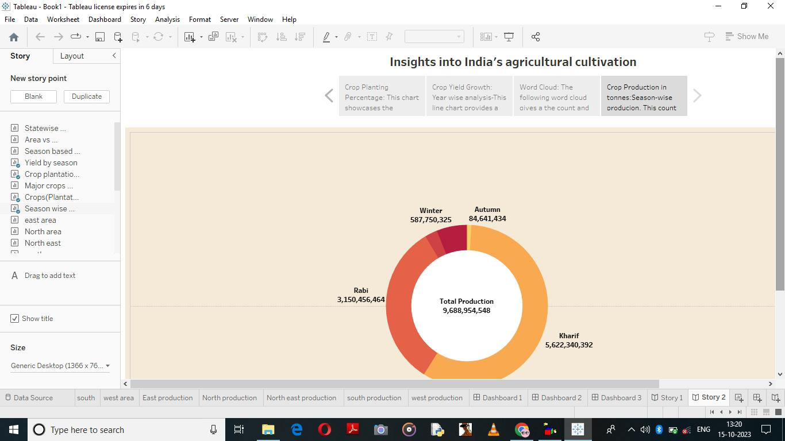

**Advantages**

1. Historical perspective: The analysis provides a long-term view of the agricultural sector, allowing for an understanding of the trends and patterns over the years. This historical perspective helps identify long-term challenges and opportunities.
2. Identification of performance drivers: Examining production trends enables the identification of factors that have influenced agricultural production, such as government policies, market dynamics, and technological advancements. Understanding these drivers can inform future strategies and policies.
3. Insights for policy-making: The analysis can provide policymakers with valuable insights into the effectiveness of past policies and interventions. This information helps in designing evidence-based policies to address challenges and support sustainable agricultural growth.
4. Decision-making support: Farmers, agricultural organizations, and stakeholders can use the analysis to make informed decisions regarding crop selection, investments, and resource allocation. It helps identify areas of growth potential and improve farming practices.
5. Future planning: By understanding the production trends and challenges, stakeholders can plan for the future and prepare for potential risks such as climate change, market fluctuations, and changing consumer demands.

**Disadvantages**

1. Data limitations: The analysis heavily relies on quality data availability and consistency. In some cases, there may be gaps or inconsistencies in the data, limiting the accuracy and reliability of the analysis.
2. Data aggregation: Aggregating agricultural production data at a national level may overlook regional or local variations. It is important to consider the diversity of India’s agricultural sector and the specific challenges faced by different regions.
3. Lack of context: Analyzing production data alone may not provide a comprehensive understanding of the agricultural sector. Factors such as input availability, access to credit, infrastructure, and social factors also influence production but may not be captured in the data.
4. Complexity and multiple variables: The agricultural sector is influenced by a range of interconnected factors, making it challenging to attribute production changes to a single cause. Analyzing production trends requires considering multiple variables and their interplay.
5. External factors: Production trends are significantly influenced by external factors such as weather conditions, global market dynamics, and policy changes. These factors are often beyond the control of stakeholders, making it challenging to predict and plan for their impact.

Despite these limitations, analyzing India’s agricultural production from 1997 to 2021 provides valuable insights into the sector’s performance, trends, and challenges. It helps inform policy-making, decision-making, and future planning for sustainable agricultural growth.

**Applications**

The analysis of India’s agricultural production from 1997 to 2021 can have various applications across different sectors and stakeholders. Some of the key applications include:

1. Policy-making: The analysis can provide valuable insights to policymakers in formulating and evaluating agricultural policies and interventions. It helps identify areas that require policy attention, understand the impact of past policies, and design evidence-based strategies for sustainable agricultural development.
2. Agricultural planning: Farmers and agricultural organizations can use the analysis to make informed decisions regarding crop selection, production techniques, resource allocation, and risk management. It helps in planning for future seasons and optimizing agricultural practices to enhance productivity and profitability.
3. Market analysis: The analysis of production trends can provide insights into market dynamics, supply and demand patterns, and price fluctuations. This information is crucial for traders, processors, and retailers in making informed decisions regarding procurement, pricing, and marketing strategies.
4. Research and development: The analysis serves as a valuable resource for researchers and scientists in studying the factors affecting agricultural production and developing innovative solutions. It helps identify research gaps, areas for technology transfer, and promising practices or technologies that can enhance productivity and sustainability.
5. Food security and nutrition: Understanding agricultural production trends is essential for assessing food availability, accessibility, and affordability. This analysis can support efforts to ensure food security, provide insights into the nutritional value of crops, and guide interventions for improving the nutritional outcomes of agricultural production.
6. Rural development and livelihood improvement: The analysis helps in identifying the challenges and opportunities in the agricultural sector, contributing to rural development. It can inform programs and initiatives aimed at improving farmers’ livelihoods, promoting sustainable practices, and addressing social and economic inequalities in rural areas.
7. Climate resilience and adaptation: The analysis provides insights into the impacts of climate change on agricultural production and helps in identifying adaptive strategies. It can guide initiatives for building resilience, promoting climate-smart agriculture, and mitigating the effects of climate change on farmers and rural communities.

The analysis of India’s agricultural production from 1997 to 2021 has broad applications across various sectors. It helps inform decision-making, policy formulation, research, market strategies, and interventions aimed at improving agricultural productivity, sustainability, and the well-being of farmers and rural communities.

**Conclusion**

In conclusion, analyzing India’s agricultural production from 1997 to 2021 provides valuable insights into the performance, trends, and challenges of the agricultural sector. This analysis offers a historical perspective, allowing for a deeper understanding of the factors that have influenced agricultural production over the years. It helps identify growth patterns, drivers of change, and areas for improvement.

The analysis serves various purposes, Including supporting policy-making, informing decision-making for farmers and stakeholders, and guiding market strategies. It provides policymakers with evidence-based insights for formulating effective agricultural policies and interventions. Farmers and agricultural organizations can use the analysis to make informed decisions, plan for the future, and improve farming practices.

Furthermore, the analysis has broader applications in areas such as market analysis, research and development, food security, rural development, and climate resilience. It helps in understanding market dynamics, identifying research gaps and opportunities, assessing food availability and accessibility, supporting rural development initiatives, and guiding climate resilience strategies.

However, it is important to acknowledge the limitations of the analysis, such as data limitations, the complexity of factors influencing production, data aggregation challenges, and the influence of external factors. These limitations should be taken into consideration when interpreting the results and making decisions based on the analysis.

Overall, the analysis of India’s agricultural production from 1997 to 2021 provides valuable insights and serves as a foundational resource for decision-makers, policymakers, researchers, and stakeholders. It contributes to the understanding of the agricultural sector’s performance, challenges, and opportunities, and supports efforts towards sustainable agricultural development, food security, and rural prosperity.

**Future scope**

Having found in more than 21 K records, Rice seems to be the most popular choice for farmers in India, followed by Mazie and Moong.

From above output we can conclude that, Uttar Pradesh, Kerala, Tamil Nadu, Karnataka, and Maharashtra are the top 5 states with highest total crop production in total for years from 1997 to 2021.

From the above output we can see that West Bengal, Uttar Pradesh, Punjab, Andhra Pradesh and Odisha are the top 5 states with max rice production

Year 2018-19, 2017-18, 2011-12, 2014-25, 2013-14 respectively had maximum crop production out of all years in the records

From the above output we can see that 1997-98 was the year with least production. This is possible due to lack of our capabilities to record the production of crops

**Appendix**

Throughout the years, India’s agricultural production has seen both successes and challenges. Here are some key statistics and trends:

1. Crop Production: India is one of the world’s largest producers of various crops such as rice, wheat, pulses, sugarcane, cotton, and oilseeds. However, the production levels of these crops fluctuate due to factors like weather conditions, pest infestations, and government policies.
2. Green Revolution: The Green Revolution, which began in the 1960s, played a crucial role in boosting India’s agricultural production. It involved the introduction of high-yielding crop varieties, improved irrigation systems, and the use of fertilizers and pesticides. This led to a significant increase in crop yields, especially for wheat and rice.
3. Livestock Production: Livestock farming is also a significant component of India’s agricultural sector. It includes production of milk, meat, eggs, and other dairy products. India is the largest milk producer globally and has a vast network of dairy cooperatives like Amul.
4. Organic Farming: In recent years, there has been a growing demand for organic food products in India and internationally. Organic farming practices, which promote the use of natural fertilizers and pesticides, have gained popularity. Several government schemes and certification agencies support organic farming in the country.
5. Government Initiatives: The government of India has launched various programs and initiatives to support farmers and boost agricultural production. These include the Pradhan Mantri Kisan Samman Nidhi (PM-KISAN), which provides direct income support to small and marginal farmers, and the Soil Health Card Scheme, which aims to promote sustainable farming practices.
6. Technology Adoption: The adoption of technology and innovation in agriculture has been increasing in India. This includes the use of precision farming techniques, drip irrigation, remote sensing, and digital agriculture solutions. Mobile applications, such as marketplaces for agricultural products, have also gained popularity among farmers.
7. Export Potential: India has a significant potential for agricultural exports due to its diverse range of agricultural products. Key export items include rice, spices, fruits, vegetables, tea, coffee, and processed food products. The government has been taking steps to promote agricultural exports through schemes like the Agricultural Export Policy.
8. Challenges: Despite the successes, India’s agricultural sector faces challenges such as fragmented landholding patterns, lack of access to credit and technology for small farmers, and post-harvest losses due to inadequate storage and transportation infrastructure. Climate change and water scarcity are also major concerns for agricultural sustainability.

In conclusion, India’s agricultural production has shown growth over the years, driven by various factors such as the Green Revolution, government initiatives, and technology adoption. However, challenges persist that need to be addressed to sustain and further enhance agricultural productivity in the country.